Java SE Project

Training And Placement Application

***AdminOptions Documentation***

1. **AdminOptionsFrame -**

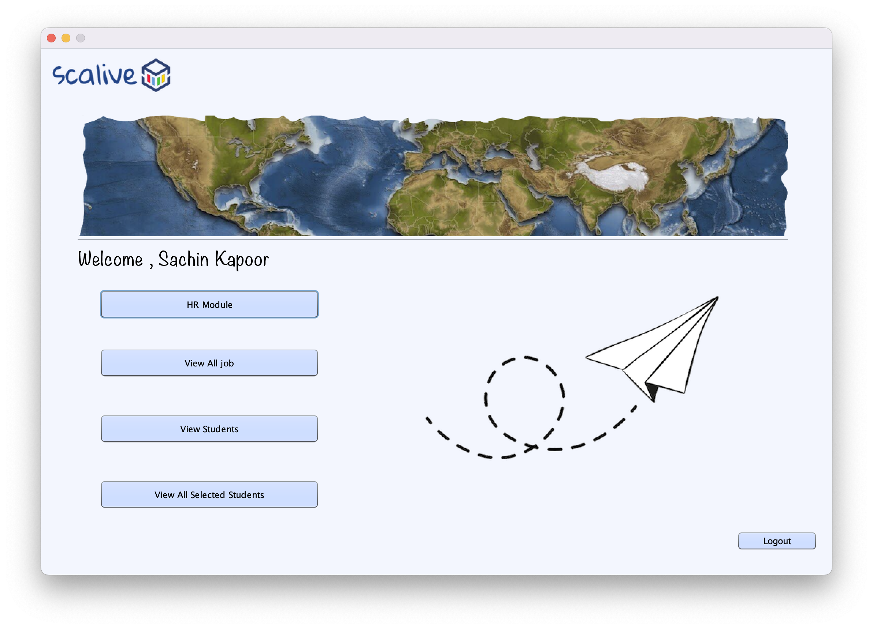

**2. STEPS TO BE DONE IN** **AdminOptionsFrame**

In the **AdminOptionsFrame** we need to do following steps:

A. Display **username**

B. Allow the user to **logout**

C. Provide the following options:

**HR Module**

**View All Jobs**

**View Students**

**View All Selected Students**

1. **Displaying The Username**

We can recall that we saved the **current user details**  in the static fields of the class **CurrentUser** . So in the constructor of **AdminOptionsFrame** we will call the **getName( )** method of the class **CurrentUser** to get the username and display it in the Label.

**public class AdminOptionFrame extends javax.swing.JFrame {**

**public AdminOptionFrame() {**

**initComponents();**

**this.setLocationRelativeTo(null);**

**lblName.setText(“Welcome “+ CurrentUser.getName());**

**}**

1. **Allowing The User To Logout**

To allow the user to logout , we will provide a button with the following functionality:

1. **When the user will click on the Button, the user will be logged out i.e. we will dispose the current frame and open the LoginFrame.**

**private void logOutBtnActionPerformed(java.awt.event.ActionEvent evt) {**

**new LoginFrame().setVisible(true);**

**this.dispose();**

**}**

**C.Handling The Options**

The next task is to allow the user to click on the buttons amongst **HR Module , View All Jobs , View Students and View All Selected Students**

To do this we need to handle the Buttons in the following way:

1. **When the button will be clicked actionPerformed of that specific button will be handled.**
2. **We will first create the object of next frame , make it visible and dispose the current frame**

**private void hrModBtnActionPerformed(java.awt.event.ActionEvent evt) {**

**new AdminHrModuleFrame().setVisible(true);**

**this.dispose();**

**}**

**3. Next step -**

After Admin validation we have to shift on next frame i.e. **“AdminHRModuleFrame”**